1. Multi-view Drawing #1
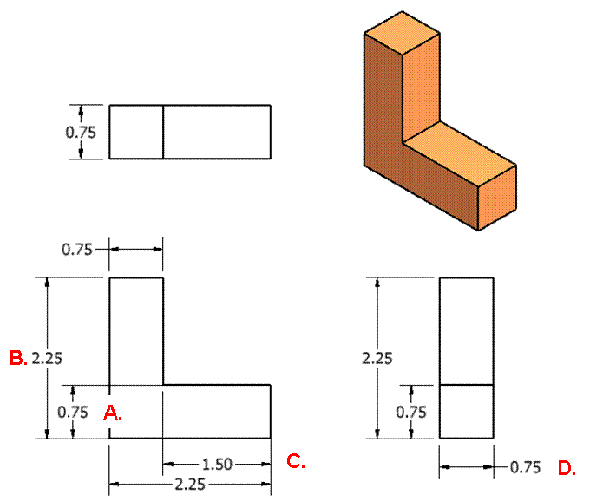
 | Dim.  Guide | Reason |  | Dim. Guide. | Reason
 | 4a  7 | Double-dimension;  wrong side |  | 4a  7 | Double-dimension;  wrong side
 | 4b  7 | Unnecessary dimension;  wrong side |  | 4a  7 | Double-dimension; wrong side

2. Multi-view Drawing #2
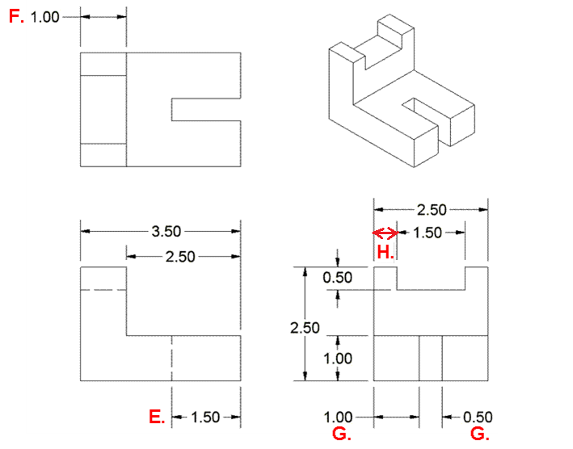
 | Dim.  Guide | Reason |  | Dim. Guide | Reason
 | 8  5 | Dimensioned to hidden line; better on top view where contour of feature is shown |  | 4b  7  5 | Unnecessary dimension; (wrong side – place between views);  (better on front view where contour of feature is shown)
 | 5  7 | Better on top view where contour of feature is shown;  (wrong side) |  | 3 | Missing dimension

3. Multi-view Drawing #3
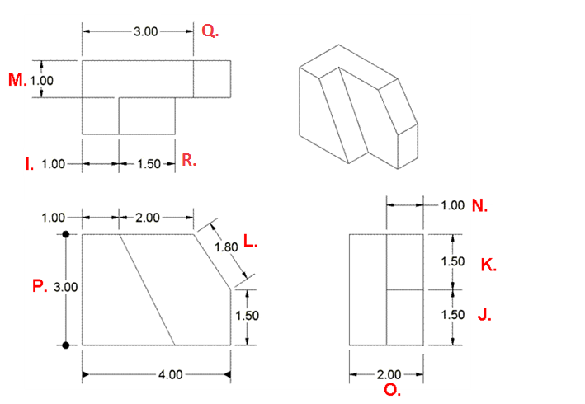
 | Dim.  Guide | Reason |  | Dim. Guide | Reason
 | 4a  5 | Double dimension;  (better on front view where contour of feature is shown) |  | 4a, 4b  7  5 | Unnecessary dimension; (wrong side – place between views);  (better on front view where contour of feature is shown)
 | 4a  7 | Unnecessary dimension; contour of feature is shown;  (wrong side) |  | 4a | Unnecessary dimension – both corners located by other dimensions
 | 7 | Wrong side;  (also a duplicate but this one should remain since shows better contour) |  | 4a | Duplicate dimension  (better on top view where contour of feature is better shown)
 | 7 | Wrong side |  | 7 | Wrong side  (do not use different arrow heads)
 | 4b | Unnecessary dimension |  | 5 | Better on front view where contour of feature is better shown (especially if adjacent 1.00 dimension is removed)

- Multi-view Drawing #4
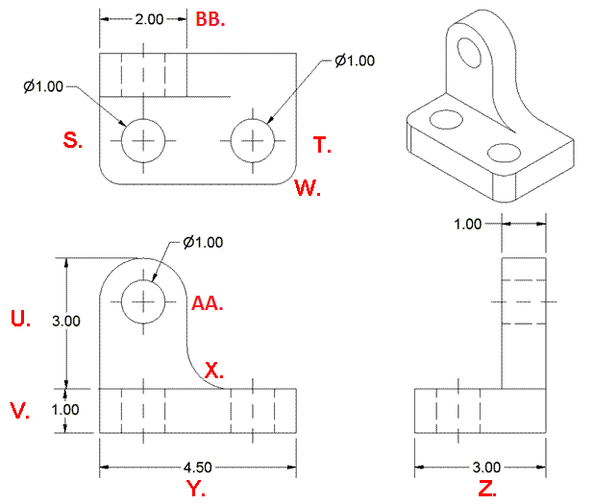
 | Dim.  Guide | Reason |  | Dim. Guide | Reason
 | 16 | Locate center of hole |  | 16 | Locate center of hole
 | 2  7 | Give overall height dimension instead of chain;  (wrong side) |  | 7 | Wrong side
 | 3 | Missing dimension (round radius) |  | 3 | Missing dimension (fillet radius)
 | 7 | Wrong side |  | 7 | Wrong side
 | 16 | Locate center of hole |  | 5 | Beeter on front view where contour of feature is shown better. Note that a radius dimension could be used instead.
Note: “2 x” could be used in the dimension of the holes on the top view in lieu of dimensioning both.

